4.1 Introduction
PC parallel port can be very useful I/O channel for connecting your own circuits to PC. Also it can be used to perform some very amusing hardware interfacing experiments.
The port is very easy to use when you first understand some basic tricks. This document tries to show those tricks in easy to understandable way. Also it illustrates how to program parallel port, but be careful, port can be damaged quite easily if you make mistakes in the circuits you connect to it .If the parallel port is integrated to the motherboard (like in many new computers) repairing damaged parallel port may be expensive (in many cases it is cheaper to replace the whole motherboard than repair that port).
Safest bet is to buy an inexpensive I/O card which has an extra parallel port and use it for your experiment. If you manage to damage the parallel port on that card, replacing it is easy and inexpensive.
The I/O port level controlling details here has proven to work well with parallel ports on the PC motherboard and expansion cards connected to ISA bus. The programming examples might not work with PCI bus based I/O cards (they can use different hardware and/or I/O addresses, their drivers' make they just look like parallel ports to "normal" applications).
The programming examples do not work with USB to parallel port adapters (they use entirely different hardware; their drivers make them to look like normal parallel port to operating system "normal" applications).
The following sections discuss all you need to know about the parallel port from concepts to code examples used to program parallel port.
4.2 Parallel port structure
PC parallel port as shown in Fig (4.1) is 25 pins D-shaped connector in the back of the computer. It's normally used for connecting computer to printer, but many other types of hardware for that port is available today. Not all 25 are needed always. Usually you can do with only 8 pins (output to outside word pins) and signal ground. This pins presented in the table below. Those output pins are ad equated for many purposes.
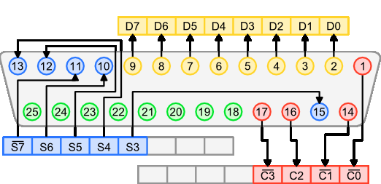
Figure (4.1): parallel port structure
Here a brief illustration of the functionality of each bin group
4.2.1 Output pins [D0 to D7]
They are 8 pins interfaced by the Data Register This is the register which allows user to write values into the Port-from computer to outside-, in simple words these pins can be used to output a specific value in data register. Or you can change voltages in specific pins they are called output pins.

4.2.2 Status pins [S4 to S7 and S3]
They are 5 pins interfaced by Status Register these are called the input pins –from outside to computer-or status register this can hold value that the outside world gives to the parallel port. So this port acts like a reader and it has 5pins for inputs.
4.2.3 Control pins [C0 to C3]
4 pin interfaced by control Register This register can be used in both the ways input and output, this is enables user to write values to outside world as well as read values from outside world but remember something most of the control pins work in invert manner you can see them with dash sign on top of the pin.
4.2.4 Ground pins [18 to 25]
Ground Pins are used as neutral these pins are used as (-) in batteries. Because if you’re connecting a device to parallel port in order to read or write you have to use one or more ground pins and read/write pin to work. For example if you’re trying to light up a LED then you have to connect (-) of the LED to a ground pin and (+) of the LED to output pin. For reading purposed use the same mechanism.
4.3 Low level view of the parallel port
Data pins are TTL level output pins. This means that they put out ideally 0V when they are in low logic level (0) and +5V when they are in high logic level (1). In real world the voltages can be something different ideal when the circuit is loaded. The output current capacity of the parallel port is limited to only few milli amperes (they outputs current of ~2.5MA). Fig (4.2) illustrates a simple idea of how you can connect load to a PC parallel port data pins.
Dn Out ------+
|+
Sourcing Load (up to 2.6 mA @ 2.4 v)
|-
Ground ------+
Figure (4.2): how to connect load to a PC parallel port data pins
It is not the only way to connect things to a parallel port. The parallel port data pins are TTL outputs, that can both sink and source current. In ordinary parallel port implementations the data outputs are 74LS374 IC totem-pole TTL outputs which can source 2.6 mA and sink 24 mA.
Regular TTL outputs Fig (4.3) basically consist of a two "stacked" transistor in series between +5 volts and ground, with the output coming from the connection between them. This is called a "totem pole output". At any given time one of these transistors is conducting and the other is not. To pull the output "high", the transistor from +5 to the output conducts (H), which "sources" positive current from the output to ground (that is, an external device between the output and ground will get power). To pull the output low, only the lower transistor (L) conducts, "sinking" current to ground; an external device between +5 volts and the output can be energized.

+5
/ |
---H on V
\ -->
|________ TTL output on = 1 = high, "sourcing" current
| out \
/ / |
---L off \ V
\_________/
Gnd

+5_________
/ \
---H off / |
\ \ V
|________/ TTL output off = 0 = low, "sinking" current
| <-- out
/
---L on |
\v Gnd

Figure (4.3): basic Regular TTL outputs
The outputs are designed so that they give at least 2.4V at 2.6 ma load. This 2.6 mA figure is for ordinary LS-TLL circuits used, the LSI implementations used in many computers can give more or less. For example quite popular (few years ago) UM82C11-C parallel port chip can only source 2 mA.
4.4 Bi-Directional Ports
Some parallel port support Bi-direction and other doesn't support Fig (4.4) shows a simplified view of the Parallel Port's Data Register. The original Parallel Port cards implemented 74LS logic. These days all this is crammed into one ASIC, but the theory of operation is still the same.
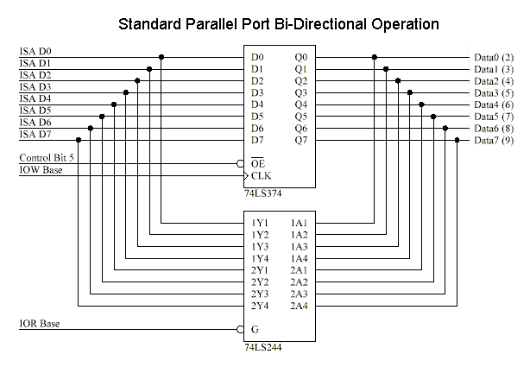

Figure (4.4): simplified view of the Parallel Port's Data Register
Bi-directional ports use Control Bit 5 connected to the 374's Output Enable so that its output drivers can be turned off. This way you can read data present on the Parallel Port's Data Pins, without having bus conflicts and excessive current drains.
Bit 5 of the Control Port enables or disables the bi-directional function of the Parallel Port. This is only available on true bi-directional ports. When this bit is set to one, pins 2 to 9 go into high impedance state. Once in this state you can enter data on these lines and retrieve it from the Data Port (base address). Any data which is written to the data port will be stored but will not be available at the data pins. To turn off bi-directional mode, set bit 5 of the Control Port to '0'.
However not all ports behave in the same way. Other ports may require setting bit 6 of the Control Port to enable Bi-directional mode and setting of Bit 5 to dis-enable Bi-directional mode, Different manufacturers implement their bi-directional ports in different ways. If you wish to use your Bi-directional port to input data, test it with a logic probe or multimeter first to make sure it is in bi-directional mode.
If your Parallel Port doesn't support bi-directional mode, don't despair. You can input a maximum of 9 bits at any one given time. To do this you can use the 5 input lines of the Status Port and the 4 inputs (open collector) lines of the Control Port.
4.5 Mains power controlling parallel port
It's possible to control mains voltage through parallel port with a suitable circuit, but when controlling mains voltage, you need to be very careful and know what you do to do it safely. Mains voltage can kill if you get in touch with it, and bad mains controlling circuit can burn down your house.
First idea for controlling mains power is to use one of the circuits to control a relay that then controls the mains power. This suit for many application as long as the relay is rated for the mains power switching application and for the current rating of your application .the relay contact is used to switch the phase/live wire going to equipment .A properly designed circuit should have in addition to the relay (plus parallel port interface circuit) also properly sized fuse that will cut the power going through the relay in case of short circuit or overload at the equipment being controlled. The fuse here is used to protect the relay against overload. A relay will work on applications where the device turned on and off quire rarely. If you are switching the device on and off often, the normal relay will suffer of limited mechanical and electrical age, and in some applications also on noise caused by sparks that are formed when relay open and close. Those sparks can cause radio frequency noise.
Another component suitable for mains voltage controlling is a solid relay. The circuits show below describe how to control a solid state relay from pc parallel port. The solid state relay controls the mains voltage.
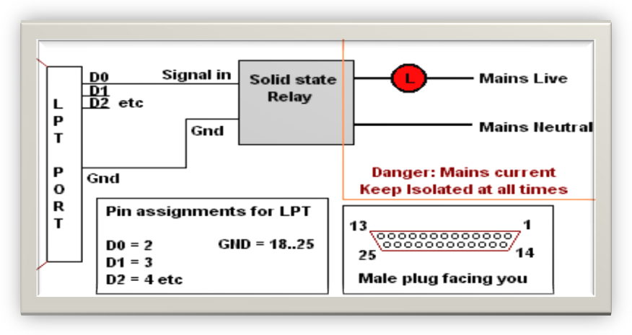

Figure (4.5): simple Application
Fig (4.5) is a simple Application, The relay for this application should be son rated for the mains voltages you send and the current your controlled equipment (marked with L on the picture) takes. The solid state relays designed for main operation provide the needed isolation between the control input and mains side.
The solid state relays should be used according to the manufacturer application notes and your local electrical equipment codes. You should keep the mains side and low voltages side Isolated in all cases (even on equipment damage case).you should also put a properly rated fuse in series with the solid state relay so protect the relay against overload. A proper size fuse will not protect the solid state relay against overheating of the load tries to take too much current through the relay. The fuse might not be able o protect the relay against short circuit damages (if you short-circuit through the load, you generally loose the solid state relay and the fuse).
Many solid state relays can be controlled directly to parallel port without extra components. you need to select solid state relay that is voltages controlled and the control voltage range can take the voltage that printer port outputs ( 5V or somewhat less). For reliable operation you should select a relay that can operate at down 3V input voltage and does not take too much control current (a SSR that takes only few mille amperes is preferred because current outputs capacity of parallel port is usually limited to that). To guaranteed that the operation is reliable with the direct connection. be sure to measure that the control voltage entering the SSR is within the specified operating range when the relay is controlled to parallel port (you can measure this without mains power applied to the rest of circuit, safer 0 measure in this way).controlling a solid relay with lower than specified control voltage can lead unreliable operation of solid state relay, and can even cause some solid state relays fail when heavily loaded.
It is also possible to build the mains voltage controlling part from discrete components. Fig (4.6), (4.7) are two circuit examples.

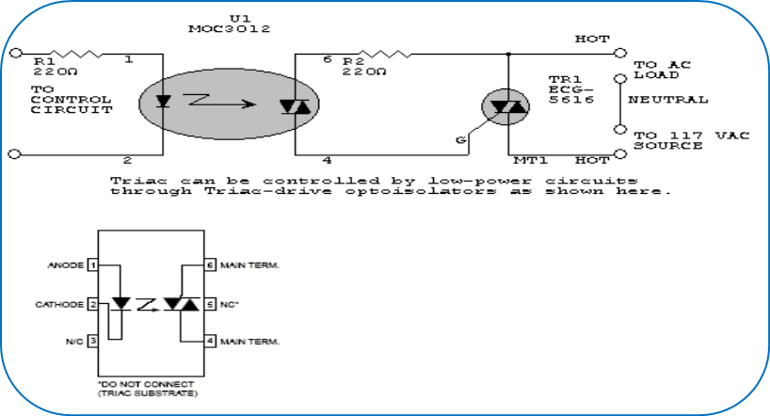
Figure (4.6): Example 1

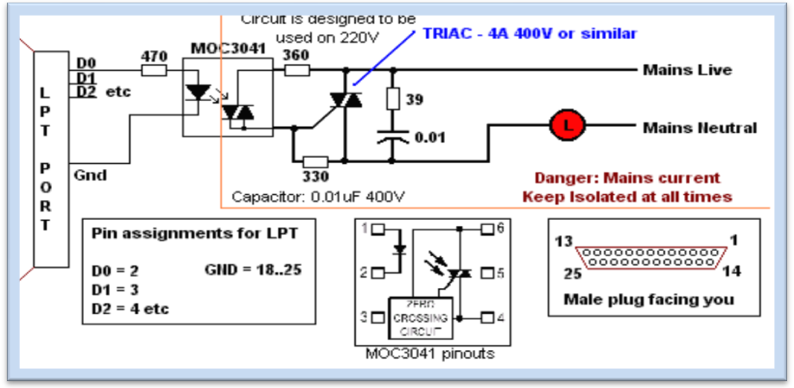
Figure (4.7): Example 2
4.6 Parallel port Programming
I know that this section is the most interesting part that reader searches for, so in this section we derive illustrative C# code fragments that describe how to read data from and write data to parallel port.

4.6.1 Addressing the Parallel Port and Registers
Port addressing controls a great deal in port programming as it is the door which enables programs to connect to the external circuit or device. Therefore I would like to explain all the available port Addresses.
In normal PCs parallel port address can be one of the addresses given below but depending on the BIOS settings and some other issues the parallel port address can be vary (but always lays in one of these address ranges)
- LPT1 03BC (hex) 956(decimal)
- LPT2 0378(hex) 888(decimal)
- LPT3 0278 (hex) 632(decimal)
As I mentioned above those are the commonly used address ranges for Parallel port and now you might be thinking of how to communicate with each of them and how do they work? Very simple! Each of those above mentioned address ranges have their own addresses for Data Register, Control Register and Status Register. So if you want to access Data register of port 888 then the Data register also 888, but if you want to access status register then add +1 to the 888 = 889 this is the status register. And to access control register what you have to do is add another +1 so it results 890 then that is the Control register of 888 based Parallel Port. If your parallel port address is different please do accordingly to find its corresponding registers. There is another simple way to check what parallel port address of your computer; you can get to know the parallel port I/O addresses through device manager. First open the device manager (start -> settings -> control panel -> system -> hardware -> device manager) as shown in Fig (4.8). Then select there the parallel port you are interested from Ports (COM & LPT) section. With mouse right button you can get menu where you select Properties. When you go through steps you will see a dialog similar to this; so locate the first item in the list box and it carries the value 0378 – 037F so this is the Address range of the printer port. Data register address is 0378 in hex or 888 in decimal.
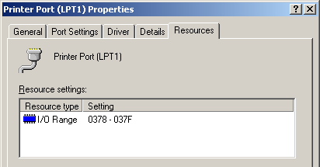

Figure (4.8): How to get parallel port address

4.6.2 Inside the code
Dealing with parallel port requires special unmanaged library file called Inpout32.dll that used to input and output data from and to parallel port; don’t forget to use the System.Runtime.InteropServices namespace you can find that
- int Inp(int PortAddress) is used to read port status with the address specified as argument.
And
- Out(int PortAddress, int Value); out puts voltages into pins corresponds to 1's in the binary representation of the passed argument, to the port with specified address.

4.6.3 Door Hardware Structure
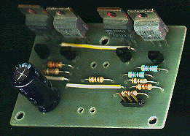
The door structure depends mainly on what is called "H Bridge" as show in Fig (4.9), "Limit Switch" Fig (4.10) and a motor as shown in Fig (4.11).

Figure (4.9): H-Bridge circuit structure

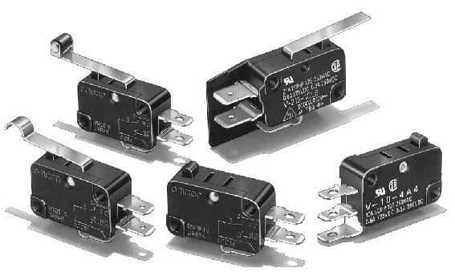
Figure (4.10): limit switches with 2, 3 pins.

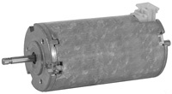
Figure (4.11): 24 Volts DC motor with 2 input pins
Let's imagine the door circuit:
- There are 7 pins in h-bridge: 2 for input which is direct AC Current, 2 for output pins which is the DC Current that is the current of motor and 3 pins for controlling motor.
  - If 1st and 2nd pins are on so motor will spin right.
  - If 2nd and 3rd are on so motor will spin left.
  - If all three pins are on motor will brake (stop spinning).
  - If 2nd pin are off so motor function are disabled.
- So when we want to open the door we will call method out (887, 2) so 1st pin is on and by default we make the 2nd pin on always
- there are 2 limit switches on the two ends of door one on the left and the other on the right end, so while motor spin it will move a piece of wood (what is called door), so when this piece touch one end so it make one of the two limit switches on and the other off, these two limit switches output pins are input to status pins of PC Parallel port , so in The application there are a thread that check the status pins each time by call method Inp( 888 ), and lets say if the 1st status pin ( pin13 ) is on so door has been opened successfully so disable current for a 5 seconds.
- after the 5 seconds call method out(889, 4) , so 3rd H-Bridge pin are on, and as we say before that 2nd control pin is on always, so motor will spin in the reverse direction , and again we read status pin values to know when door successfully closed, and finally stop current by call method out(889 , 0).

4.6.3.1 Circuit Programming
After you know how to read and write from parallel port it is time to show how to use it in opening and closing The door but first you must know what pins involved in The door circuit, referring to Figure 3.1 are:-
- Pin12 input from door corresponds to S5
- Pin2 output to door corresponds to D0
- Pin3 output to door corresponds to D1
- Pin13 input from door corresponds to S4
- Any ground pin from the eight pins
You have to know that the Opening and Closing door follow these criteria
  - Check door status whether it is opened or in between close it.
  - if request to open, output 0x1H to Data register and launch thread that continuously check the door status to see whether door opening finished or not ,if so output 0x0H to stop motor.
  - if request to close door, output 0x2H to the data register and launch a thread that continuously reads door status to see whether door closing finished or no if so the output 0x0H to stop motor .
  - and this can be shown in code below:
public void Open_The_Door(object state)
{
int Status;
lock (this)//ban any other thread in the same application to alter //this shared resource
{
//open The Door
porting.Out(Configuration.LptPortAddressBase, PINOPEN);
doorStatus = DoorStatus.InWork;

while (true)
{
Thread.Sleep(50);
Status = porting.Inp(Configuration.LptPortAddressBase + 1);
if (Status == SP_DOOROPEND)
{
//Stop Motor Or you Can replace it by 3
porting.Out(Configuration.LptPortAddressBase, PINSTOP);
doorStatus = DoorStatus.Opened;
break;
}
//this case occur when the two limit switch are on, & this is Hardware Failure

else if (Status == 72)
{
//Stop Motor Or you Can replace it by 3
porting.Out(Configuration.LptPortAddressBase, PINSTOP);
doorStatus = DoorStatus.Unknown;
break;
}
}//end while loop

//wait To Enter
Thread.Sleep(Configuration.WaitOnOpened);

//Close The Door
porting.Out(Configuration.LptPortAddressBase, PINCLOSE);
//Set The Status
doorStatus = DoorStatus.InWork;

while (true)
{
Thread.Sleep(100);
Status = porting.Inp(Configuration.LptPortAddressBase + 1);
if (Status == SP_DOORCLOSED)
{
//Stop Motor Or you Can replace it by 3
porting.Out(Configuration.LptPortAddressBase, PINSTOP);
doorStatus = DoorStatus.Closed;
break;
}
else if (Status == 72) //this case occur when the two limit
//switch are on, & this is Hardware Failure
{
porting.Out(Configuration.LptPortAddressBase, PINSTOP);
doorStatus = DoorStatus.Unknown;
break;
}
}
}
}

